

PRAYAS
Matching the humane

PHASE -2
SYSTEM PROCESSES
IDENTIFYING THE SYSTEM PROCESSES IN PRAYAS

SUBMITTED TO - DR.DURGANSH SIR
SUMITTED BY -
NAME - ARUSHI SHAH
ROLL NO - 11
SAP ID - 500070104
GROUP NAME - THE SOULED
GROUP MEMBERS -
VATSALYA TEGWAL78
SURMAI ADHIKARI 80
ARUSHI SHAH 11

PROCESSES

PRAYAS IS DIVIDED INT0 TWO MAJOR PROCESSES:

- development process
- Project management

PROCESS DONATION -

ALGORITHM-
- The online open platform prayaas will provide options to the user i.e donations options.
Donation options -
1.staionary
2.books
3.blankets (daily essentials )
4.cloths(new,old,usable)
5.SECURE DONATION - under secure donation money donation will be done under secure network as security of OTP and secure USER ID.

- Users will choose from donations which donation he/she wants to make. Once the donation is chosen .PRAYAS will let users see all the databases of different NGOs which are around their diameter . users can choose by their preference which NGO they will donate into.
- After step 1 and step 2, A delivery will get scheduled by prayas. At the instance the user taps the donate button . pickup and delivery will get scheduled. User will get the acknowledgement from the delivery service .on their respective mobile phone from which they have login before
- After step 1,2,3. A receipt of acknowledgement will be sent to both the parties donor and receiver .
- Taking donations from one place to another will be the work of employees.i.e delivery executives . once the donation takes place will move to step 6.
- Once the user receives the donation an acknowledgement msg will be sent to the donor that their parcel is being received by “receiver’s name “. Thus PRAYAS provides transparency to donor and receiver.
- After step 6 . donar will earn coins through prayas, which will later change into money and can be submitted to their respective bank account

SECURE DONATIONS

- Step 1 and 2 will be the same .
- Prayas will show different option from which users can donate money :
1.online
2.cash
3.draft

- The money transaction will be done on the secured network by PRAYAS with the data of user i.e name ,contact,attached account,gmail. Users can choose the payment amount and can easily donate money through easy payment options .
- After step 3 . users will get acknowledgement that Respective NGOs have got the cash donation from users.

PROCESS MAPPING (NGO MAPPED WITH OLD AGE HOMES)
ALGORITHM -

- There will be two seperate data one for different NGOs. and another will be old age homes . from step 2 there will be various steps to map the old age home with orphange childrens

- The orphanage data and the old age home data will be merged according to nearest locations .eg. if an orphanage is close to or in a diameter of any old age home then the data will be merged together.

- prayas allows only validated facilities to register and provides contact details and map locations for assistance

- After step 1,2,3 Prayas allows old-age homes and orphanages to sign up and organise meetings, thus facilitating children and senior citizens to spend time together.

- Seminars,activities will be planned and launched on the website itself.

- The meeting can be fixed between the two parties according to the merged data

PROCESS DATABASE
How prays will get the data of different ngos

ALGORITHM
- Determine the purpose of your database -Database is required so the other processes access it and give the desired results to the users and whoever accessing the website .

- Find and organize the information required.- search on the web,and other social media handles to acquire the data as well as different ngo own websites.which will be helpful for collecting the data of owners,childrens.

- Divide the information into tables. - after step 3 the database will be converted into different tables such as seperate tables for users,employees,children.

- Turn information items into columns - add the consecutive information in the different tables which will give rise to the actual data which can be manipulated accordingly using sql commands.

- Specify primary keys - identifying the separate unique keys for each table so that identifying the data will become easy and handy.by specifying the primary key we can make relationships with different tables which contain the different data which should be manipulated or should be used on the desired conditions. For eg. The primary key in an employee will be service no., for users the primary key will be a unique id from which they will login into prayas. And for children the PK will be ngo’s unique ID of a child.

- Set up the table relationships - There will be 3 main tables: employee,users,ngo,old age home. And all other tables will be referencing from these tables by foriengn key which will be taking reference from the primary keys.

- Refine your design - the different tables and database which is input of these tables will be refined. the unnecessary data will get deleted to decrease the complexity of the data . thus unwanted data which is not required for the purpose shall be deleted to work effectively.

- .Apply the normalization rules- After step 1,2,3,4,5,6,7 . now the data will get rady and mutable. We can apply different normalization forms like 1N,2N,3N in order to reduce data redundancy and improve data integrity.Redundancy in relation may cause insertion, deletion and updation anomalies. So, it helps to minimize the redundancy in relations.

DFD LEVEL 2 DIGRAMS FOR RESPECTIVE PROCESS.
FOR DONATION --

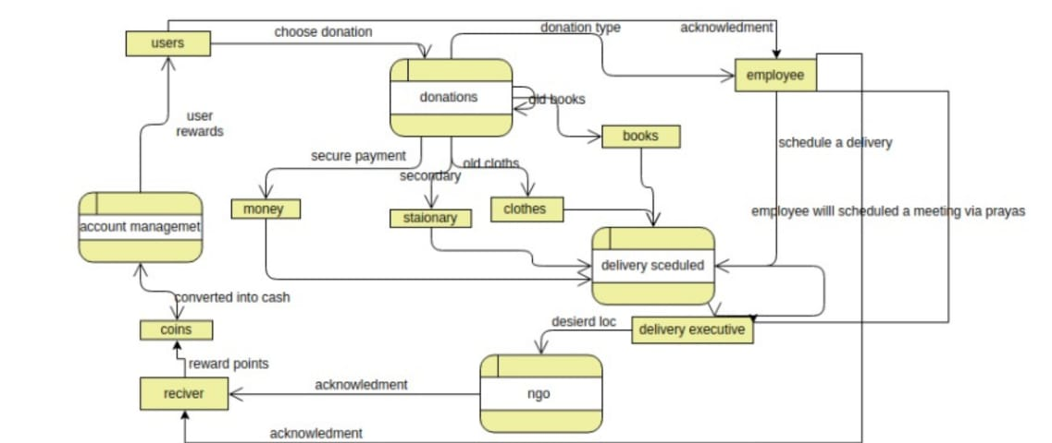

FOR DATABASE --
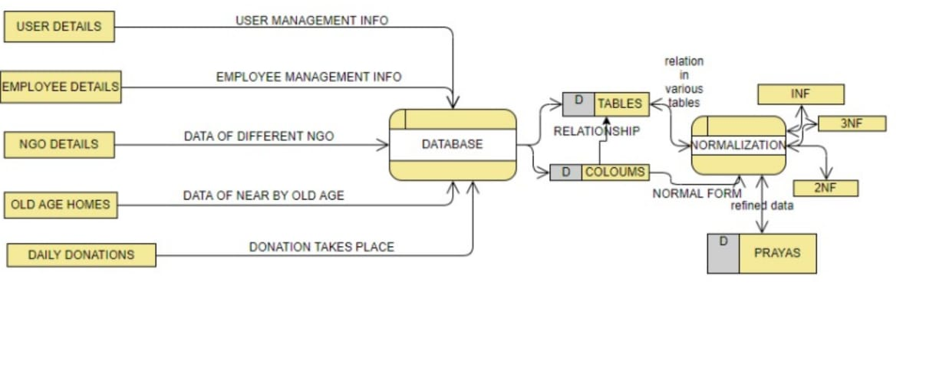

FOR MATCHING --

